SMART WATER

FOUNTAINS

INTRODUCTION

Water fountains have become very popular over the last irrigation facilities that uses sensor technology to sense the moisture level of the soil with a microcontroller in order to make a smart switching electronic device to help billions of people. Irregular watering leads to the mineral loss in the soil and may end up with rotting the plants.

HIGH-LEVEL REQUIREMENT LIST:

• Able to drain the polluted water and replace it with fresh water. Specifically, the polluted water will be drained by a motor-controlled valve to the “polluted water temporary storage tank” part. After completing the draining process, fresh water will be pumped from the general water supply(as described in the right down corner of the physical design.

• The fountain must accurately monitor the water quality, including measuring water temperature up to 48.89C and pH values between 6.5 and 8.5.

• Able to be connected to the users’ devices through WIFI. Prompt feedback from the smart water fountain to users’ interface with relevant information including the remaining water level and water quality index: ‘Good’, ‘Average’ and ‘Poor’.

HARDWARES

1.Fountain Hardware

2.IoT Device(microcontroller)

3.Water Level Sensor

4.Control Mechanism

5.Sensors

6.Power Supply

7.Internet Connectivity

8.LED

9.Water Pump

10.Tubing

FUNCTIONALITY

1.Remote Control

2.Automated features

3.data analytics

4.safety

5.energy efficiency

SENSORS

Temperature Sensor: A temperature sensor is a device or component that measures temperature and converts it into a corresponding electrical signal or digital output. These sensors are widely used in various applications, including industrial processes, climate control systems, consumer electronics, and scientific research. Temperature measurement is essential in many fields to monitor and control processes, ensure safety, and gather data for analysis.

Temperature sensors play a crucial role in various industries, including HVAC (heating, ventilation, and air conditioning), automotive, aerospace, food processing, and healthcare, among others. They enable precise control and monitoring of temperature-related processes, contributing to efficiency, safety, and product quality.

PH-sensor: A pH sensor, also known as a pH probe or pH electrode, is a specialized instrument used to measure the acidity or alkalinity of a solution, typically in terms of its pH value. pH is a measure of the concentration of hydrogen ions (H+) in a solution, and it is a fundamental parameter in chemistry, biology, and many industrial processes.

key components

1. Glass Electrode

2. Reference Electrode

3. Junction

4. Connector

5. Maintenance and Calibration

Conductivity sensor: A conductivity sensor, also known as a conductivity probe or conductivity electrode, is an instrument used to measure the electrical conductivity of a solution. Conductivity is a measure of a solution's ability to conduct an electrical current, which is primarily determined by the concentration of ions (charged particles) present in the solution. Conductivity sensors are widely used in various fields, including chemistry, environmental monitoring, water quality assessment, and industrial processes.

key components

1.Probe or Electrode

2. Cell Constant

3. Temperature Sensor

4. Connector

5. Maintenance and Calibration

Conductivity sensors are versatile instruments that provide valuable insights into the composition and quality of solutions, making them indispensable in a wide range of scientific, industrial, and environmental applications.

Liquid Level Sensor: A liquid level sensor, also known as a level transmitter or level sensor, is a device used to detect and measure the level of a liquid in a container or reservoir. These sensors are crucial in various industries and applications, including manufacturing, process control, environmental monitoring, and more. Liquid level sensors come in various types and technologies, each suited for specific conditions and requirements.

SOLUTION

The project is to design a smart water fountain that can monitor the water quality and automatically replace water polluted .we will use sensors to measure the water quality. Common water quality measurement factors include temperature, PH-value, conductance, turbidity and hardness. Considering the pollution at home can only affect limited factors, we choose temperature, PH-value and conductance to be the three properties used for calculating water quality in our water fountain.

EXAMPLE IMAGES

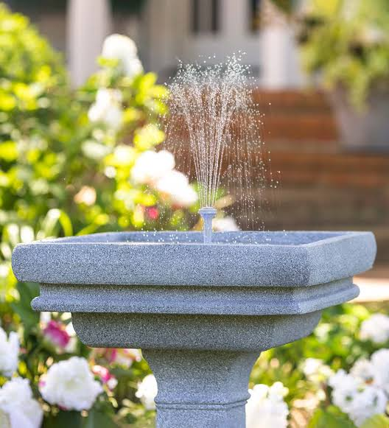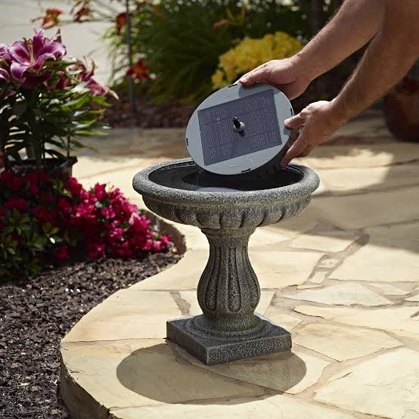  
Conclusion

Implementing IoT technology in a smart water fountain offers a myriad of benefits, including real-time monitoring, automation, and enhanced user experiences. By integrating Sensors, data analytics, and remote control capabilities, a smart water fountain becomes more efficient, user-friendly, and environmentally conscious.it can proactively manage water levels, quality, and energy consumption, ensuring optimal performance, and resource conservation.

THANK YOU